Sierra Brown

Adaptive force generation for precision-grip lifting by a spectral timing model of the cerebellum

**Introduction**

The “Adaptive force generation for precision-grip lifting by a spectral timing model of the cerebellum” by Ulloa, A., Bullock, D., and Rhodes, B, illustrates how the process of grasping and lifting an object is controlled. The agent must apply a weight and texture dependent grip force that applies the minimal amount of pressure to hold the object, while also applying the appropriate load force to either lift, or lower the object. The model explains this phenomena through the process of learned slip-compensation mediated by the cerebellum.

A predecessor for this model is the Adaptation of the Vestibular – ocular –reflex model in 1974. An image slip error signals that head rotation is necessary in order to maintain a point fixed in vision. This is implemented by Purkinje cells of the flocculus region of the cerebellar cortex which inhibit cells in the vestibular nuclei. This model operates based on the same principle, with slip error signals causing learning in the cerebellum and an eventual transition from reactive to anticipatory grip forces.

The motor cortex and cerebellum play large roles in the control of precision grip, as evidenced by a close link between primary motor cortex activity and precision grip force. As shown by lesion and GABA agonist studies, when the motor cortex is not fully functional, actors must use whole hand prehension rather than precision grip. The motor cortex enables the actor to selectively activate one or a few effectors rather than all of them. Another key component is the dentate nucleus of the cerebellum (which projects to the MI via the thalamus). When it is impaired it also severley impairs precision grip. For example, monkeys will use 1 finger to retrieve food from a hole rather than 2 fingers in a pincer like movement. Furthermore, it causes a loss of anticipatory phasic components of MI cell discharges and switches from an efficient phasic strategy to a costly tonic strategy, resulting in a loss of cerebellar timing. The intermediate zone of the cerebella coretex, nucleus inrepositus also modulates grip.

The timing and variation of precision grip force is also closely linked to the timing of load force. The two have to work in conjunction to properly grip and lift an object. Though load force and error works in a similar fashion to grip force the main focus of this model is grip force control, with the goal of formalizing the role of MI and cerebellum in learned transitions from reactive to anticipatory application of grip forces whole magnitudes are texture and weight dependent.

**Model Components**

**Arm**

While the model primarily focuses on grip force, in order to portray a holistic image of the process, it is necessary to understand how grip force relates to load force. The two have to operate in harmony in order to properly grasp, lift, and lower an object. On typical trials it was shown that grip force increased first, followed by a parallel increase in load force, there was a stabilization of load force as the object was held in the air, and the load force was released slowly below the force of gravity as the object lowered, and then released all together with grip force as the object reached the table. Load force rises faster with weight, although it is not affected by texture as is Grip force, which is a function of both weight and texture.

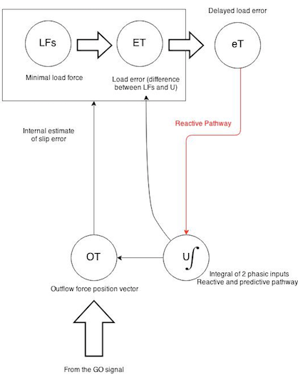

Load force error calculations and learning take place in a way that is parallel to the grip aperture circuit. It will not be explored as in depth as the grip aperture circuit, however the basic circuitry is described in Fig 1. It operates by calculating the difference between the minimal load force required and the output produced by the predictive and reactive pathways, in order to correct and move towards more predictive input on the following trial.

The model achieves this by calculating the integral of the two phasic inputs (U) and using that information to update the outflow force position vector. As the error is reduced in each trial the outflow force becomes progressively more reliant on predictive input than reactive.

**Grip Aperture Component**

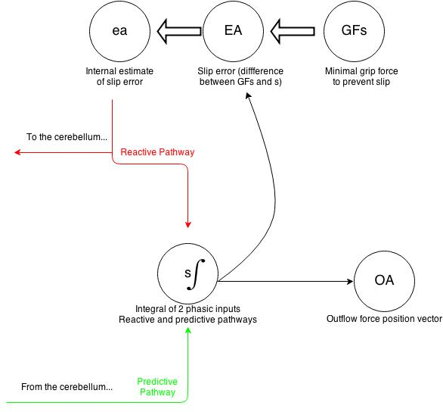The grip aperture component functions based on two inputs, a reactive component as well as a predictive one. To calculate these two, the initial comparative number is the minimal grip force required, which is calculated as a function of weight and texture. The reactive component is then calculated by computing the error between the necessary grip force and the currently applied grip force. The predictive component is computed using the initial error as well, however that is computed in the cerebellum. The integrals of the two components is taken and passed on as output of the grip aperture circuit to actually move the hand.

As learning in the cerebellum progresses and error is reduced, the predictive input will have a greater influence on hand movement than the reactive input.

**Cerebellar Side Loop**

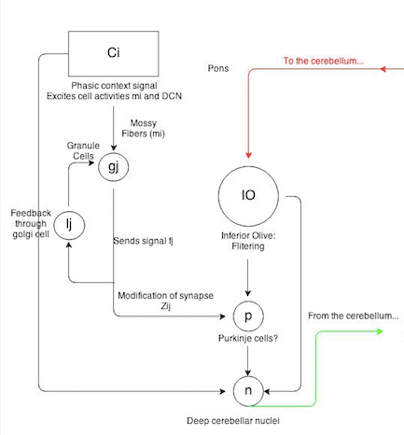The cerebellar component is where learning occurs that will allow the entire circuit to rely more on predictive than reactive input.

First a phasic context signal excites mossy fibers, which activates granule cells and deep cerebellar nuclei. Positive feedback through the golgi allows the network to mainintain the context signal in working memory throughout the process. Learning does not occur at this connection.

The granule cells then send singal fj to purkinje cells. This synapse is labeled Zij, and this is one of the most important parts of the circuit, where learning actually occurs. Here either slow LTP or fast LTD can be experienced.

The inferior olive filters information sent from the grip aperture component about error on the previous trial.

All of this information then converges on the deep cerebellar nuclei which then sends information to the final outflow force position vector, which will instigate movement. The information about what the final result of the outflow force position vector will also be fed back into the grip aperture system for the next set of error calculations.

**Matlab**

Illustrate and explain matlab code features needed to change arrays of synaptic weights an save values of such variables across a set of simulated trials, so that they can be plotted.

1. Arrays of zeros representing the initial synaptic weights is are created that are the length of the time array (number of trials).

W = zeros(size(time)); % w represents the current summed synaptic strength

W_dot = zeros(size(time)); %w_dot represents the current synaptic strength

W_storage = zersos(numtrials, length(time));

Z_storage – zeros(numtrials, 40, length(time));

1. After each trial, synaptic weights are updated

If trial > 1

w(: ) = w_storage(trial-1,end); % The new synaptic strength is set equal to

for k = 1: 40

z(k, : ) = z_storage(tiral – 1, k, end

end

end

1. The synaptic weight change occurs during each trial

Z_dot(:,i) = f( : , i) = f ( : , i). * (beta_zLTP*(1-z(:, I -1)) – beta_zLTD * h(eA(i), eA_dot(i))

Z( : , i) = z (: , i – 1) + z_dot( : , i) . *dt;

w_dot (i) = m(i) * (alpha_w * w(i-1) + beta_w * (1-w(i-1)) * h(eA(i),eA_dot(i)) * z( : , i-1 ));

w(i) = w( i – 1) + w_dot (i) * dt;

1. Synaptic weights w and z1 through z40 are stored in memory for the next trial, so that the system can learn from one trial to the next

w_storage(trial, : ) = w ;

z_storage(trial, : , :) = z;

**Results**

The simulation results show the process of the error signal adjusting control from reactive to anticipatory.

**Evolution of eA:**

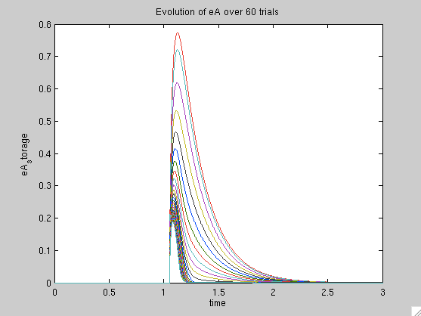With each progressive trial, the error value decreases as the actual action is closer to the desired action. As the error value decreases, the necessity for reactive feedback decreases and control is scaled up for anticipatory feedback.

**Grip force transition from reactive to anticipatory**

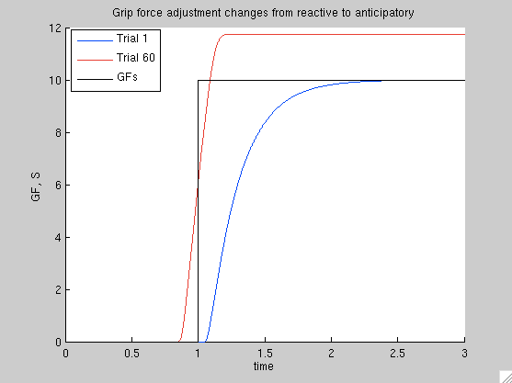Grip force in the beginning is strengthened only as the feedback signal relates to the system that there has been an error, at which point it incrementally corrects itself until reaching the necessary value. By Trial 60, anticipatory control is the main input, which allows the correct grip force to be achieved more quickly.

**Parallel Fiber Activity**

Regardless of the stage of learning, parallel fiber activity remains constant.

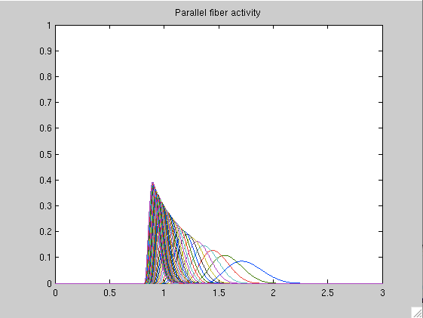

**Parameter Adjustment**

Applying the appropriate size error signal to the system is crucial for its ability to mediate learning at the optimal rate. I scaled gamma_eA up and down in order to observe the changes it induced. I found this interesting due to its relationship to the PID controller, where adjusting the gain had a large impact on the efficacy of the system.

|  |  |  |
| --- | --- | --- |
| Gamma_eA Adjustment | eA Signal | Reactive vs Anticipatory grip force |
| .04 |  |  |
| .16 |  |  |

**eA Signal:**

When a larger error signal is applied, error signals are sent overall over less time duration, because the correction will occur much faster.

**Grip force:**

The correction of grip force also occurs much more quickly when the error signal is larger. This could cause overestimation, though, as occurred in the PID controller.

**Discussion**

In conclusion, the model achieves the purpose of formalizing the role of MI and cerebellum in learned transitions from reactive to anticipatory application of grip forces whole magnitudes are texture and weight dependent. I believe the strongest, and yet simplest, part of the model is the way the slip error signal drives change in the system. After learning about Euler’s method, this strategy of correcting previous error is very clear and it seems logical that a physical grip force can be determined in this fashion. Furthermore, the transition from reactive to anticipatory input by learning in the synapse between mossy fibers and DCN cells is illustrates how this input is actually applied.

An interesting expansion of this model could include widening the model to include information about the interaction of memory as a driver of anticipatory grip forces. As mentioned in the discussion of the paper, memory of previous experience gripping and lifting an object is stored for later use. Incorporating the impact of memory and the distortions innately involved in memory in this model could be interesting. How well do we mentally calculate the weight and texture of objects before we actually lift them? How many trials are required before a subject memorizes the weight of a certain type of item – for example, a coffee cup? Are some people naturally more adept at this, and does this translate to increased performance in physical activities such as sports?

Furthermore, an incorporation of visual information into the model would also be interesting. Is visual feedback primarily used in order to determine whether or not an object has reached its goal height, or proprioceptive information, and is one type of feedback more effective that the other? Modeling these types of inputs could make the model richer.

This model could also be extremely useful in building robots, or any type of system that responds to external physical input. A robot which not only had pre-programmed information about how to lift certain objects, but could improve mobility on different terrains through learning could be very useful. For example, a roving device such as an automatic lawnmower, or google car, could have preset information about how much power it should apply on different types of terrains. However, on certain locations, such as a particularly bumpy piece of road in San Francisco, it could learn through feedback the right amount of power to apply, and perform better at that location in the future.

Finally, the clear use of the PID controller concept within this model makes it universally accessible to those in engineering disciplines which makes it easily adoptable and clearly demonstrates how the cerebellum works.